NIH Data Management and Sharing
Required For All NIH Grants That Generate Scientific Data:
- Submission of a 2-page Data Management and Sharing Plan (DMSP)
- Documentation of compliance with the approved plan
Which data should be shared?
- Appropriate data to validate and replicate findings from published studies
- Data from a study even if not directly linked to a publication
- Null findings that do not result in a publication
What doesn’t fall under the policy?
- Laboratory notebooks
- Preliminary analysis/optimizations
- Case report forms
- Physical objects or specimens
- Manuscript drafts, correspondence

Acceptable Reasons Not to Share:
- Explicit federal, state, local, or Tribal law, regulation, or policy prohibits disclosure
- Concerns around privacy or safety of research participants
- Pre-existing consent policies or agreements prohibit sharing of participant-derived material
- Digitization of datasets is impractical
How Can this Affect a Grant?
- Can request funds for DMS
- Reviewed by NIH staff
- Does not impact scoring
- The DMSP may be updated as the project evolves (approved by sponsor)
- Noncompliance may impact future funding decisions for the recipient institution
Elements of DMSP
- Data Type
- Related Tools, Software and/or Code
- Standards
- Data Preservation, Access, and Associated Timelines
- Access, Distribution, or Reuse Considerations
- Oversight of Data Management and Sharing

NIH Sharing:
https://sharing.nih.gov/

Kraemer Family Library: https://kfl.uccs.edu/services/finding-open-repositories

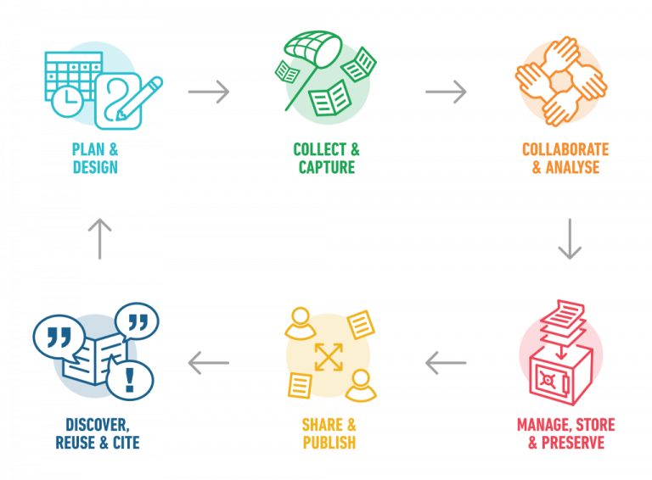
NIH Data Management and Sharing

Figure 1: Gaelen Pinnock, CC BY-SA 4.0 , via Wikimedia Commons

To learn more, please visit the UCCS NIH Data Management and Sharing Website.
Principal Investigator Human Subjects Items to Consider When Developing a DMS Plan
- Review NIH Sharing Data from Human Participants
- Consider how research participant data will be shared.
- Consider how research participants will be informed their data will be shared (i.e., de-identified using HIPAA de-identification standard or identifiable. This is managed by the research team.)
  - How will this be addressed in the informed consent form and the IRB application?
- When submitting an NIH funded proposal to the UCCS IRB include your DMS plan to the IRB for general awareness. Please note the IRB may ask some follow-up questions or make requests to ensure the DMS plan follow federal regulations and campus policies.
- If using Genomic Data, review NIH Genomic Data Sharing Policy.
If you have questions, please reach out to the IRB@uccs.edu.

NIH Sharing:
https://sharing.nih.gov/

Kraemer Family Library: https://kfl.uccs.edu/services/finding-open-repositories

